Chapter 19, Solution 68.

For the upper network 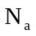, 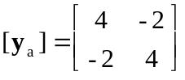

and for the lower network 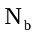, 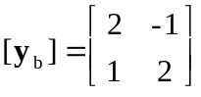

For the overall network,
